|  |  |  |  |
| --- | --- | --- | --- |
| **Product Name** | IOT Gateway with WiFi | **PCB No. / Revision No.** | **CMS 938 Rev 0** |
| **PCB Name** | **CPU card** | **Date** | **11-11-2024** |

|  |  |  |  |  |  |  |  |
| --- | --- | --- | --- | --- | --- | --- | --- |
| Si No. | Interface | Pin No. | GPIO No. / Signal Name | Signal Direction | Application | Function | Action |
| 1. | USB | 69 | USB Data+ | Bidirectional | Upload/download firmware to module  To access the module | - | 1.Default configuration  2.Connect USB cable between PC to J3 jumper  3. Short the jumper JP1 for upload/download firmware  4. Remove jumper JP1 for normal operation. |
|  | 70 | USB Data- | Bidirectional |
| 2. | Debug UART | 12 | UART TXD | Digital Output | EC25 module Debug port. | - | 1. Default configuration  2. Connect console cable between PC to J4 through USB-to-Serial cable. |
| 11 | UART RXD | Digital Input |
| 3. | Main UART | 67 | UART TXD | Digital Output | Meter communication port#1 | Meter data communication via RS232 / RS485 | 1.Default configuration |
| 68 | UART RXD | Digital Input |
| 4. | I2C  Note: Check serial no. 5 for GPIO expander config. | 41 | I2C CLOCK | Open Drain | I2C to GPIO expander and RTC |  | 1. I2C driver need to enable  2. GPIO expander driver need to enable  (IC :PCF8574DWR, Make : Texas)1  3. RTC driver need to enable  (IC : DS1307, Make : Maxim/Analog)2 |
| 42 | I2C DATA | Open Drain |  |
| 5. | I2C to GPIO | 4 | GPIO03 | Digital Output | Signal Strength#1 | LED should glow, if signal strength >75% | LED ON → GPIO = 0(Low)  LED OFF → GPIO = 1(High) |
| 5 | GPIO13 | Digital Output | Signal Strength#2 | LED should glow, if signal strength >50% | LED ON → GPIO = 0(Low)  LED OFF → GPIO = 1(High) |
| 6 | GPIO23 | Digital Output | Signal Strength#3 | LED should glow, if signal strength >25% | LED ON → GPIO = 0(Low)  LED OFF → GPIO = 1(High) |
| 7 | GPIO33 | Digital Output | Signal Strength#4 | LED should glow, if signal strength <25% | LED ON → GPIO = 0(Low)  LED OFF → GPIO = 1(High) |
| 9 | GPIO4 | Digital Input | Cloud Status LED | As per the Software development document | LED ON → GPIO = 0(Low)  LED OFF → GPIO = 1(High) |
| 10 | GPIO5 | Digital Input | WiFi Configuration Switch | Switch is used to configure the device | GPIO=1 → Normal Mode  GPIO=0 →WiFi Configuration mode |
|  |  | 11 | GPIO6 | Digital Input | Default Switch | Switch is used to load default configuration of the device | GPIO=1 → Normal Mode  GPIO=0 → Default configuration Mode |
|  | 12 | GPIO7 | Digital Input | Digital Input2 | To connect external Digital input devices. | GPIO=1 → DI not detected  GPIO=0→ DI detected  (LED D23 should glow) |
| 6. | I2C to RTC | 5 | I2C CLOCK | Open Drain | Real Time Clock | To get current date and time | 1. Need to set the date and time after download linux& firmware |
| 6 | I2C DATA | Open Drain |
| 7. | GPIO | 1 | GPIO34 | Digital Output | WDT Input pulse | To monitor the system. If any unknown behavior in occurs then reboot the system by stopping WDT input pulse | 1.POR → GPIO=0  2. Normal Operation → GPIO1 = 1 to 0 (delay : min 100µS)  This pulse should be repeating continuously every 30sec once. Stop this pulse to reboot the system. |
| 8. | GPIO | 2 | GPIO45 | Digital Output | SIM select | To select SIM between SIM1 and SIM2 | SIM 1 → GPIO = 1 (High)  SIM 2 → GPIO = 0 (Low) |
| 9. | GPIO | 1 | GPIO1 | Digital Input | Digital Input1 | To connect external Digital input devices. | GPIO=1 → DI not detected  GPIO=0→ DI detected  (LED D23 should glow) |
| 10. | GPIO | 2 | GPIO2 | Digital Output | Digital Output1 | To connect external Digital output devices. | DOEnable→ GPIO = 1(High)  (LED D25 should glow)  DO Disable → GPIO = 0(Low) |
| 10. | GPIO | 5 | Net Mode3 | Digital Output | Indicate the module’s network registration mode. | SIM registered in 4G LTE network or other network. | Default Configuration.  LED ON → SIM registered in 4G LTE  LED OFF → SIM registered in Other networks |
| 12 | GPIO | 6 | Net Status3 | Open Drain | Indicate the module’s  network activity status | 4 types of LED blinking will happen to indicate the activity | Default Configuration.  LED blinking (200ms ON/1800ms OFF) → Network Searching  LED blinking (1800ms ON/200ms OFF) → Idle  LED blinking (125ms ON/125ms OFF) → Data transfer is ongoing  LED ON → Voice Calling |
| 13 | GPIO | 61 | Modem Status3 | Open Drain | Indicate the module’s operation status | Indicate the module operation | Default Configuration.  LED blinking → Module Powered ON and working normal operation mode. |
| 14. | SDC 2 | 23 | SD_INS_DET | DI | To interface SD card | To store the data from the module | Default configuration. |
| 28 | SDC2_DATA3 | I/O |
| 29 | SDC2_DATA2 | I/O |
| 30 | SDC2_DATA1 | I/O |
| 31 | SDC2_DATA0 | I/O |
| 32 | SDC2_CLK | I/O |
| 33 | SDC2_CMD | I/O |
| 16. | GNSS | 47 | GNSS Antenna | - | To track the location | - | Default Configuration. |
| 17. | SDC 1 | 129 | SDC1_DATA_3 | I/O | Wireless Connectivity Interface | To Interface with WLAN SDIO of FC20 | Default configuration. |
| 130 | SDC1_DATA_2 |
| 131 | SDC1_DATA_1 | I/O |
| 132 | SDC1_DATA_0 |
| 133 | SDC1_CLK | DO |
| 134 | SDC1_CMD |
| 18. | COEX_UART | 137 | COEX_UART_RX | DI | Wireless Connectivity Co-existence signal | To coexistence with LTE/WLAN/BT | Default configuration. |
| 138 | COEX_UART_TX | DO |
| 19. | WLAN/ ENABLE | 136 | WLAN_EN | DO | Wireless Connectivity enable signal | To enable/disable WLAN function | WLAN_EN 🡪 1  WLAN function will enable  WLAN_EN 🡪 0  WLAN function will disable |
| 20. | PM Enable | 127 | PM_ENABLE | DO | WLAN Power control | To enable/disable WLAN Power | PM_ENABLE 🡪 1  WLAN power will enable  PM_ENABLE 🡪 0  WLAN power will disable |

Note:

1. GPIO expander IC information’s are,
   1. I2C Bus slave 8-bit Read Address : 65(Decimal), 41(Hexadecimal)
   2. I2C Bus slave 8-bit Write Address : 64(Decimal), 40(Hexadecimal)
   3. After POR need to configure the ports to act as a input and output. Write 1- Input & 0 – Output.
   4. Datasheet link is, [scps068j.pdf (widen.net)](https://rocelec.widen.net/view/pdf/zsmwgcsqj9/scps068j.pdf?t.download=true&u=5oefqw)
2. RTC IC information’s are,
   1. I2C Bus slave 8-bit Read Address : 209(Decimal), D1(Hexadecimal)
   2. I2C Bus slave 8-bit Write Address : 208(Decimal), D0(Hexadecimal)
   3. Date and Time format: MM/DD/YY DOW HH:MM:SS
   4. Datasheet link is, [ds1307.pdf (analog.com)](https://www.analog.com/media/en/technical-documentation/data-sheets/ds1307.pdf)
3. Front Panel LED’s position

|  |  |
| --- | --- |
| LED No. | LED Name |
| 1 | System Power |
| 2 | Signal Strength#1 |
| 3 | Signal Strength#2 |
| 4 | Signal Strength#3 |
| 5 | Signal Strength#4 |
| 6 | Cloud Status |
| 7 | Net Status |
| 8 | Digital Output#1 |
| 9 | Digital Output#2 |
| 10 | Digital Output#1 |

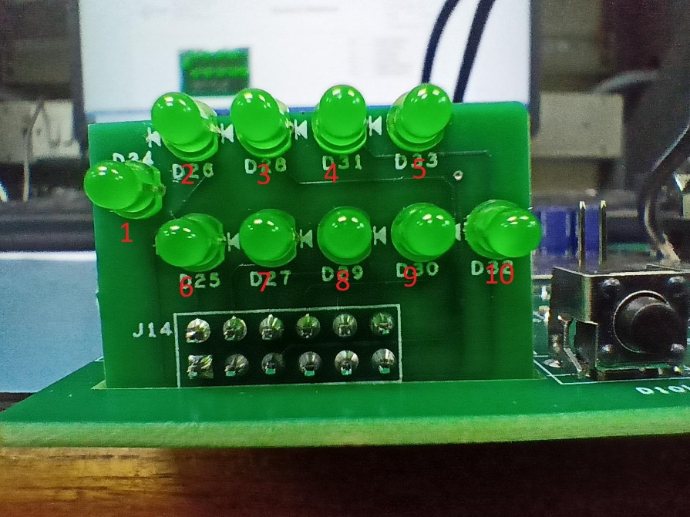

1. To enable WDT jumper JP1 pin no. 1&2 should be short. To disable WDT JP1 pin no. 2&3 should be short. WDT timeout period is 28Sec.
2. In PCB top side connector is SIM2(U9) and bottom side connector is SIM1(U12). Need to check the appropriate SIM Act LED after enabled each SIM card.

|  |  |  |  |  |  |  |  |  |  |  |  |
| --- | --- | --- | --- | --- | --- | --- | --- | --- | --- | --- | --- |
| **Prepared by** | | | | **Tested by – Hardware** | | | | **Tested by - Software** | | | |
| Sign |  | Date |  | Sign |  | Date |  | Sign |  | Date |  |